## 2.3.4 Custom Build Screen

### 2.3.4.1 Purpose

* This view allows the user to prepare and save a build that is custom.
* The user gets to make many choices regarding different aspects of a build that fit their needs, including:
  + Character
  + Role
  + Rune Selection
  + Starting items
  + Starting skills
  + Skill order
  + General items
* This view gets the user closer to accomplishing their goal by giving them the freedom to create and experiment with their own builds to see what is best for their needs.
* The user can access this page by pressing a special button for this option in the build list view.
* Users have several options to where they can go from this view:
  + The user can discard any changes made and go back to the previous view (build list).
  + The user can save any changes made and go back to the previous view (build list).
  + The user can press a button on the page itself regarding an option and be switched to a view that is specialized to that option (tbd).
  + The user can access the Hamburger layout and switch to any of the views listed under it.

2.3.4.2 Wireframe Screenshot  
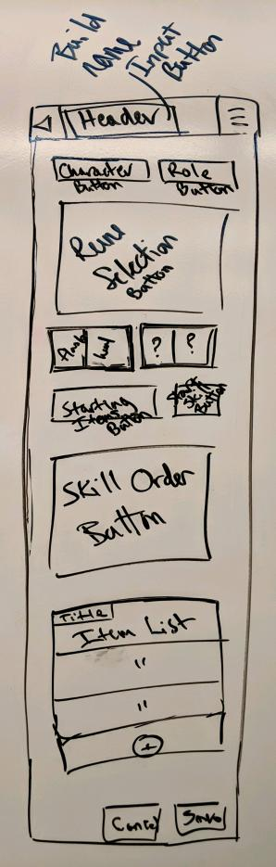  
2.3.4.3 Mockup Screenshot  
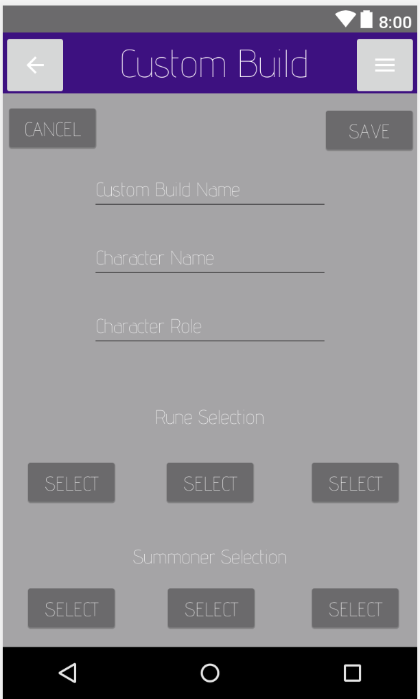

### 2.3.4.4 Prototype Screenshot Screenshot of prototype for this interface goes here.

### 2.3.4.5 Design Commentary

Talk about how your UI changed as it went through the steps of Wireframe -> Mockup -> Prototype. What did you like / dislike at each stage that influenced the next round of UI development?